**PYTHON PROJECT REPORT**

**TOPIC :- TRANSFERMARKET**

**GITHUB Project link** :- https://github.com/045045fsm/Python_project_045045.git

**SUBMITTED BY** :- **SUBMITTED TO** :-

Rishi Goswami **Prof. Amarnath Mitra**

Roll no. 045045

**PROJECT OBJECTIVE :-**

The project aims to scrape, compile, visualise and interpret comprehensive football player transfer data from multiple European leagues, including the Premier League, La Liga, Bundesliga, Serie A, and Ligue 1.

**GENERAL DESCRIPTION OF DATA :-**

The dataset comprises detailed football player transfer information from major European leagues, including the Premier League, La Liga, Bundesliga, Serie A, and Ligue 1.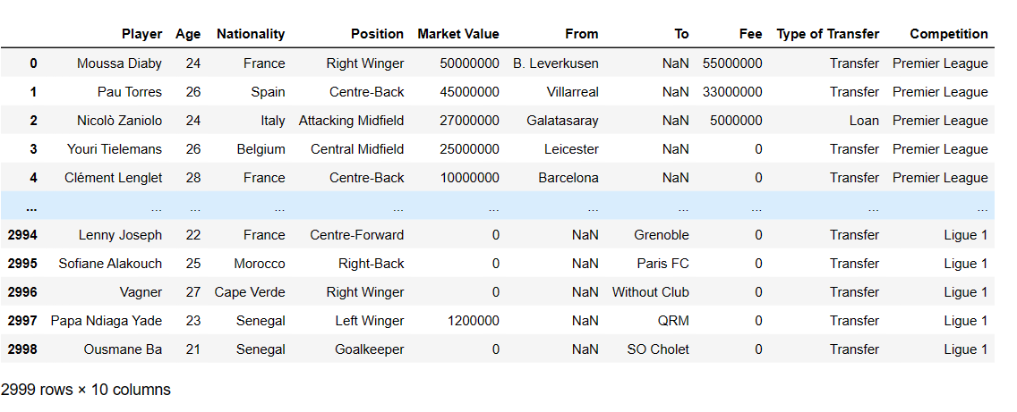 Different column represents the information of the players’ age, nationality, position, market value, competition, transfer fees and type of transfer.

**ANALYSIS :-**

**Visualization 1**: Age Distribution of Transferred Players

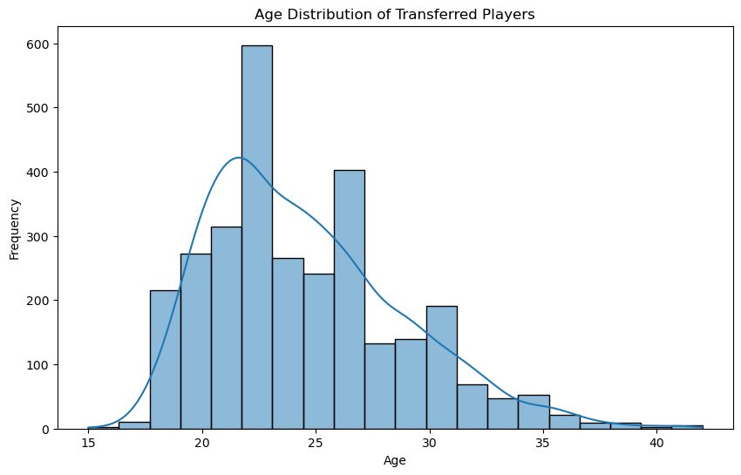

***Interpretation 1***: The age distribution shows that most transferred players are in their early to mid-20s, with a peak around 23-25 years old.

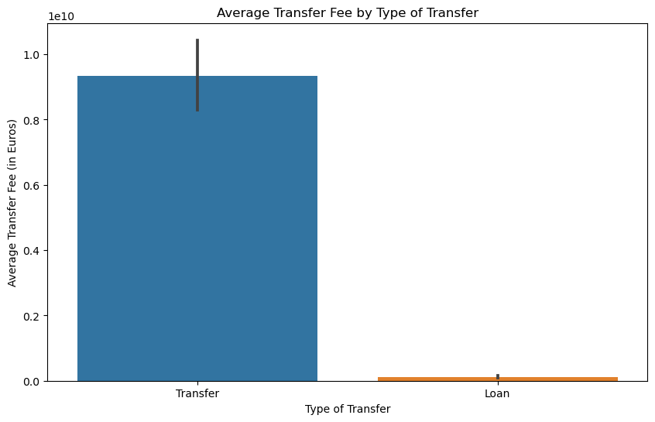**Visualization 2**: Average Transfer Fee by Type of Transfer

***Interpretation 2***: The bar chart compares the average transfer fees for different types of transfers (Loan and Permanent Transfer). It appears that permanent transfers generally involve higher fees than loan deals.

**Visualization 3**: Top 10 Nationalities of Transferred Players

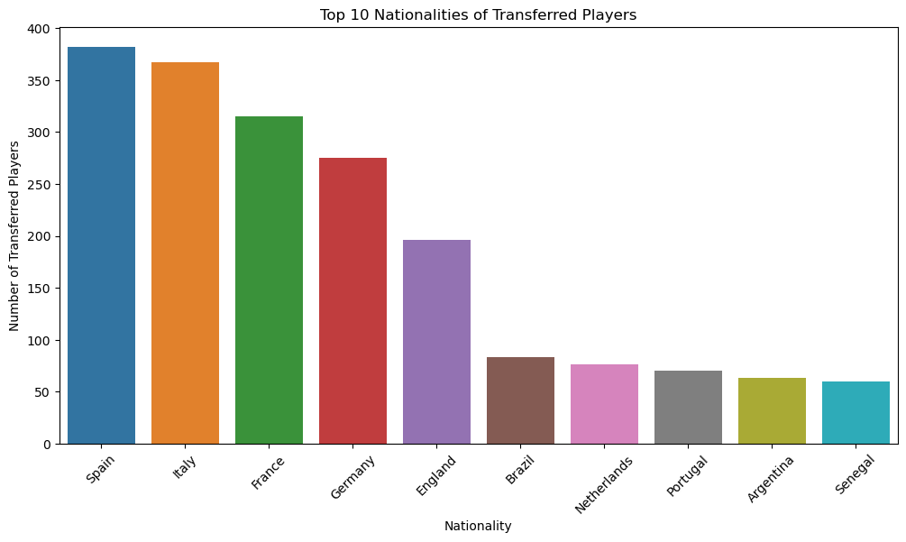***Interpretation 3***: This bar chart displays the top 10 nationalities of transferred players. It provides insights into the diversity of nationalities represented in the transfers.

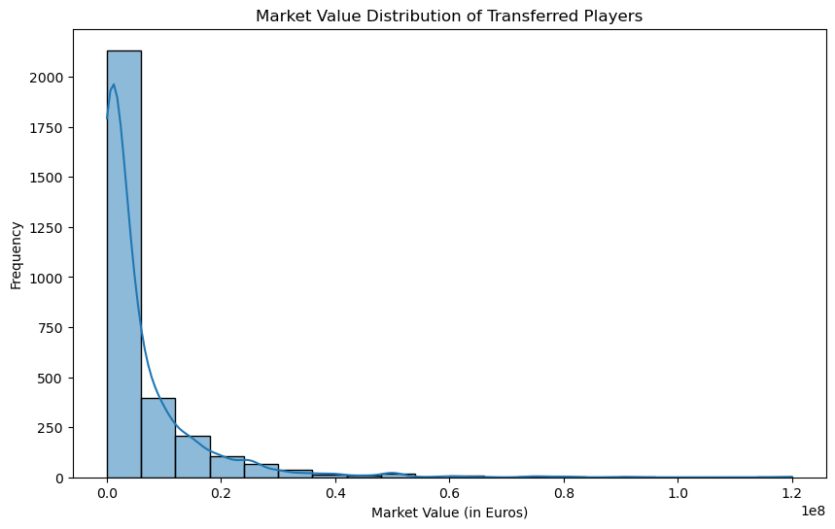**Visualization 4:** Market Value Distribution of Transferred Players

***Interpretation 4***: The market value distribution indicates that most transferred players have market values clustered in the lower range, but there are also players with higher market values.

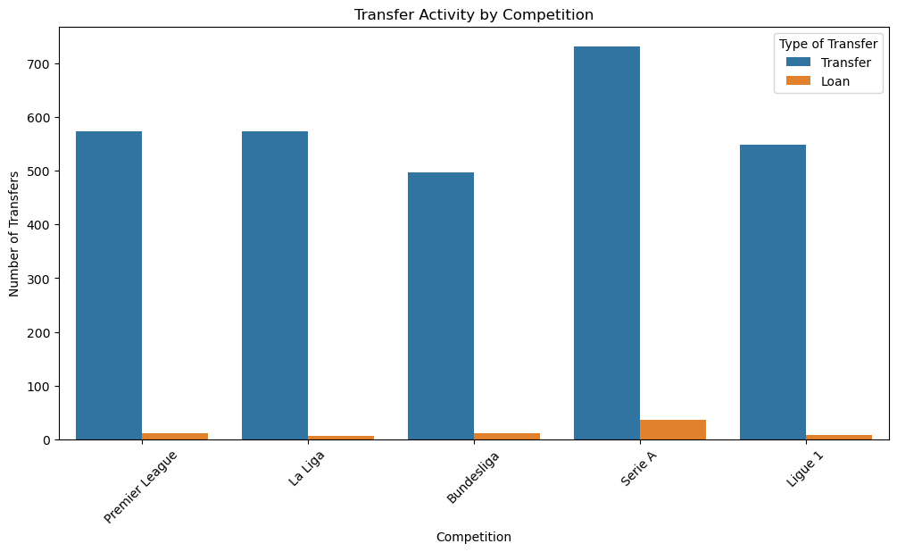**Visualization 5**: Transfer Activity by Competition

***Interpretation 5:*** This count-plot shows the transfer activity (loan and permanent) in different competitions. It helps identify which leagues have the highest transfer activity.

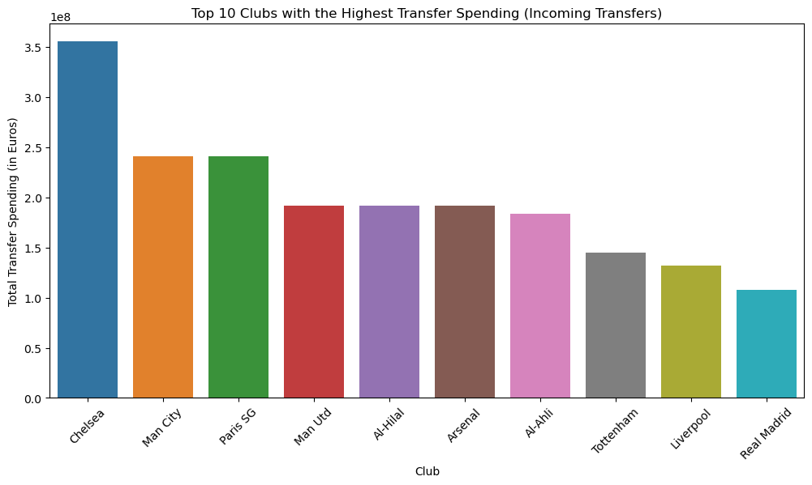**Visualization 6**: Top 10 Clubs with the Highest Transfer Spending

***Interpretation 6***: This bar chart displays the top 10 clubs with the highest transfer spending on incoming transfers. It provides insights into which clubs are investing heavily in acquiring new players.

**Visualization 7**: Position Distribution of Transferred Players

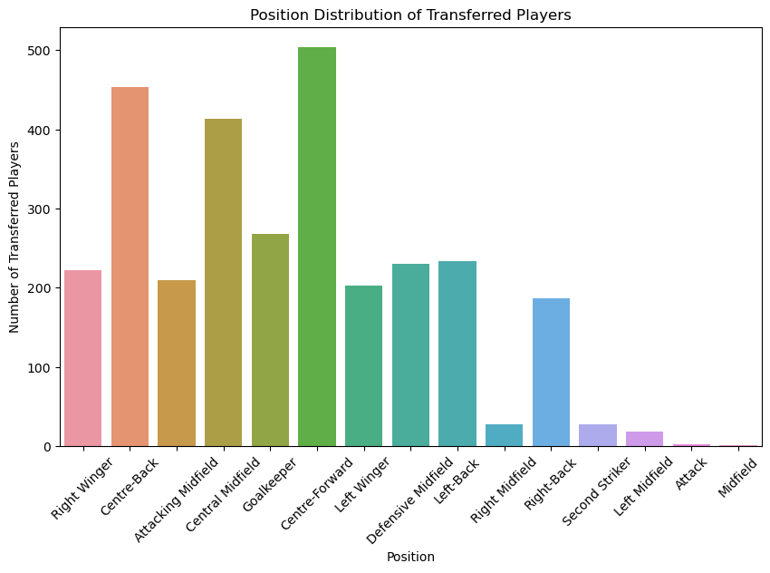

***Interpretation 7***: This count plot illustrates the distribution of transferred players by position. It provides insights into which positions are in high demand in the transfer market.

**Visualization 8**: Average Transfer Fees by Competition

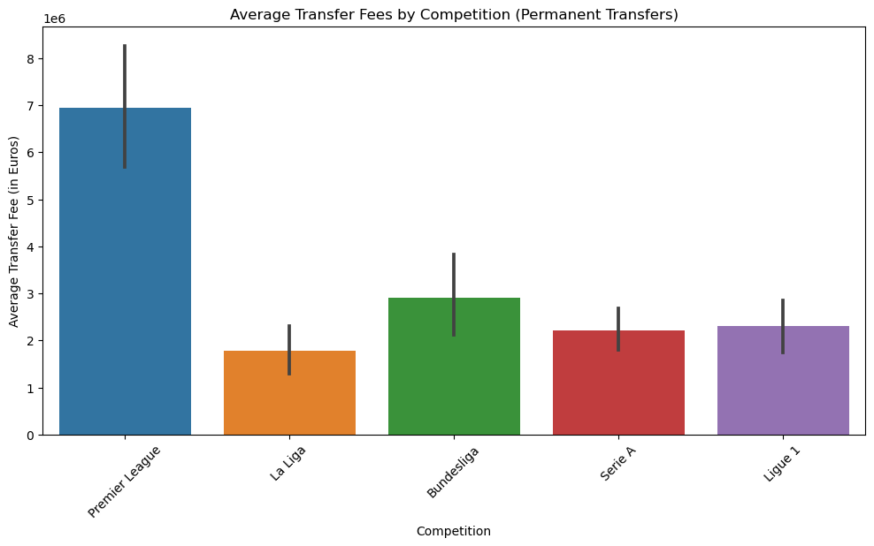

***Interpretation 8***: This bar chart displays the average transfer fees for permanent transfers in different competitions. It helps identify which leagues tend to have higher average transfer fees.

**Findings & Inferences :-**

The analysis of football player transfer data has revealed several key findings and inferences. Firstly, the age distribution of transferred players indicates a significant focus on young talents in their early to mid-20s. Secondly, permanent transfers involve higher average fees compared to loan deals. Thirdly, the top 10 nationalities of transferred players highlight regions of frequent scouting. Moreover, market value distribution varies widely, aiding negotiations. Transfer activity by competition reflects the dynamics in different leagues, and top clubs exhibit substantial spending. Position distribution and average fees by competition assist in targeting specific positions and assessing financial landscapes. These findings enhance recruitment, financial planning, and negotiation strategies in football transfers.

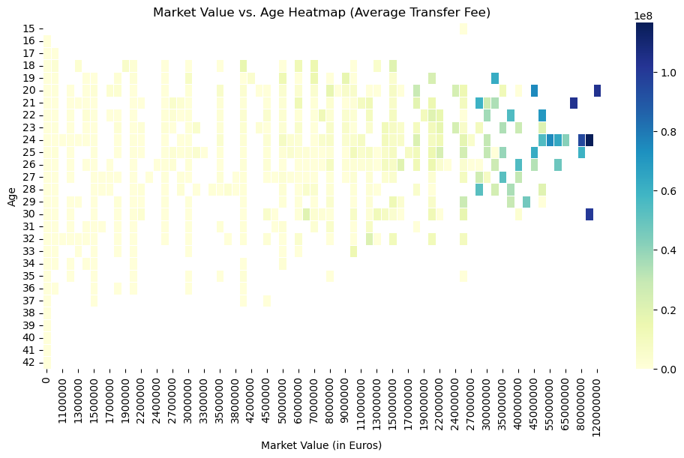

***Inference*** : The heatmap displays the relationship between market values, player ages, and average transfer fees. It helps identify how market values and ages correlate with transfer fees.

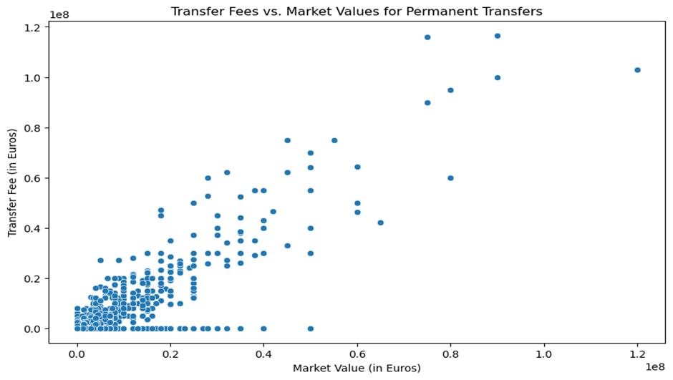

***Inference***: The scatter plot shows the relationship between transfer fees and market values for permanent transfers. It helps identify whether clubs are paying higher fees for players with higher market values.

**Managerial Insights | Implications :-**

1. **Player Recruitment Strategy**: Clubs can use the age distribution analysis to fine-tune their player recruitment strategy. Understanding that the majority of transfers involve players in their early to mid-20s suggests that clubs often seek young talent with the potential for long-term development.
2. **Financial Planning**: The visualization showing higher average transfer fees for permanent deals implies that clubs need to budget more effectively for permanent transfers compared to loan deals.
3. **Market Value Assessment**: It can help in negotiations and setting realistic expectations for player valuations.
4. **Competition Analysis**: Understanding the transfer activity by competition is essential for clubs seeking to compete at the highest level.
5. **Position-Specific Recruitment**: The position distribution analysis highlights which positions are in demand. Clubs looking to strengthen specific positions can use this data to identify potential transfer targets.
6. **Player Valuation Strategy**: Clubs can use the market value vs. age heatmap to develop a player valuation strategy. Understanding how age and market value correlate can help clubs make informed decisions on when to buy or sell players.